Relāciju datu modeļa datu tipi

2D punkts un klasteris. 2D punktu elementi ir elementi, kas sastāv no divām koordinātēm X un Y, kas tiek lietoti garuma un platuma norādīšanai.
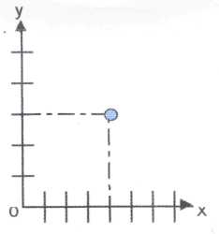
2D līniju virknes. Līniju virknes sastāv no viena vai vairākiem punktu pāriem, kas definē līniju segmentus.
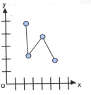
2D n-punktu daudzstūri.
Daudzstūri sastāv no savienotām līniju virknēm, kas veido aizvērtu gredzenu. Daudzstūri, kas pārklāj cits citu nav pielietojami. Lai iegūtu nepieciešamo veidu, lieto līniju virknes, kas krustojas. Ja līnijas krustojas pašas ar sevi, tad tas nenozīmē, ka veidojas daudzstūris.
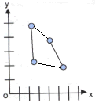

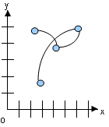
Relāciju-objektu datu modeļa tipi

2D līniju loku virknes.

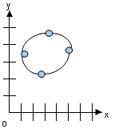
2D loku daudzstūri.

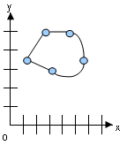
2D savienojamie daudzstūri.

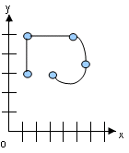

2D savienojamās līniju virknes.

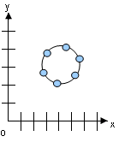
2D riņķi.

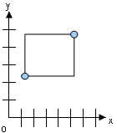

2D optimizētie taisnstūri.

Ģeometrisko datu modeļa hierarhiska struktūra

Telpisko datu modelis ir hierarhiska struktūra, kura sastāv no elementiem, ģeometrijas, slāņiem, kuri atbilst telpisko datu attēlojumiem (ceļu slānis, ēku slānis); koordinātu sistēmas (x un y) un precizitātes. Slāņi tiek veidoti no ģeometrijas, kura tiek veidotas no elementiem.

elementi | Ceļi – līnijas; ēkas – daudzstūri; zaļā zona – līniju virknes
ģeometrijas | Ceļu, ēku, zaļo zonu koordinātu tīkls
slāņi(layers) | Sadalījums vienā līmenī
koordinātu sistēma | x un y pāri katrai līnijai, kas ir platums un garums
precizitāte | Skaitlisks, lielums, kas nozīme precizitāti metros

Elements ir ģeometrijas pamata bloks. Atbalstītie elementu tipi ir atkarīgi no izvēlētā modeļa tipa, piemēram, relāciju modeli tie ir punkti, līniju virknes, un daudzstūri. Katra koordināta elementā tiek glabāta kā X un Y pāris, bet punkta dati satur tikai vienu koordinātu pāri,. līnijas – divus pārus. Ārējais un iekšējais daudzstūra gredzens ir divi dažādi elementi, kas veido komplicēto daudzstūri. Daudzstūra dati satur koordinātu vērtību pārus, katrs pāris – vienam daudzstūra segmentam.
Ģeometrija ir lietojuma telpiskās īpašības attēlojums, kas ir modelēta kā primitīvo elementu kopa. Ģeometrija relāciju un relāciju-objektu modeļos ir atšķirīga.
Slānis ir ģeometriju heterogēna kolekcija, kas sastāv no ģeometrijām, kurām ir vienāda atribūtu kopa. Piemēram, viens ĢIS slānis satur informāciju par ceļiem, otrs par ēkām utt., slāņu skaits nav ierobežots.
Koordinātu sistēma jeb telpiskā raksturojuma sistēma ir koordinātu sasaiste, kas ļauj interpretēt veidoto objekti pozīcijas. Koordinātu sistēma var būt ģeogrāfiska rakstura, kad standarta mērvienība ir metri, un neģeogrāfiska, kad lietotājam ir iespēja lietot savas mērvienības.
Precizitāte tiek lietota, lai asociētu precizitātes līmeni ar telpiskajiem datiem. Tās vērtība ir pozitīvs skaitlis, kas lielāks par nulli. Precizitātes vērtība ir metrisks skaitlis.
LOĢISKĀ MODEĻA IZVEIDOŠANA

Līmeņi (layers):
- zaļā zona (līniju virknes);
- ceļi (līniju virknes);
- ēkas (n-punktu daudzstūri);
- brīvs zemes gabals (poligons).
ēkas

ceļi
zaļā zona
brīvs zemes gabals

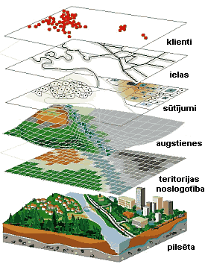

Sākotnējais attēls

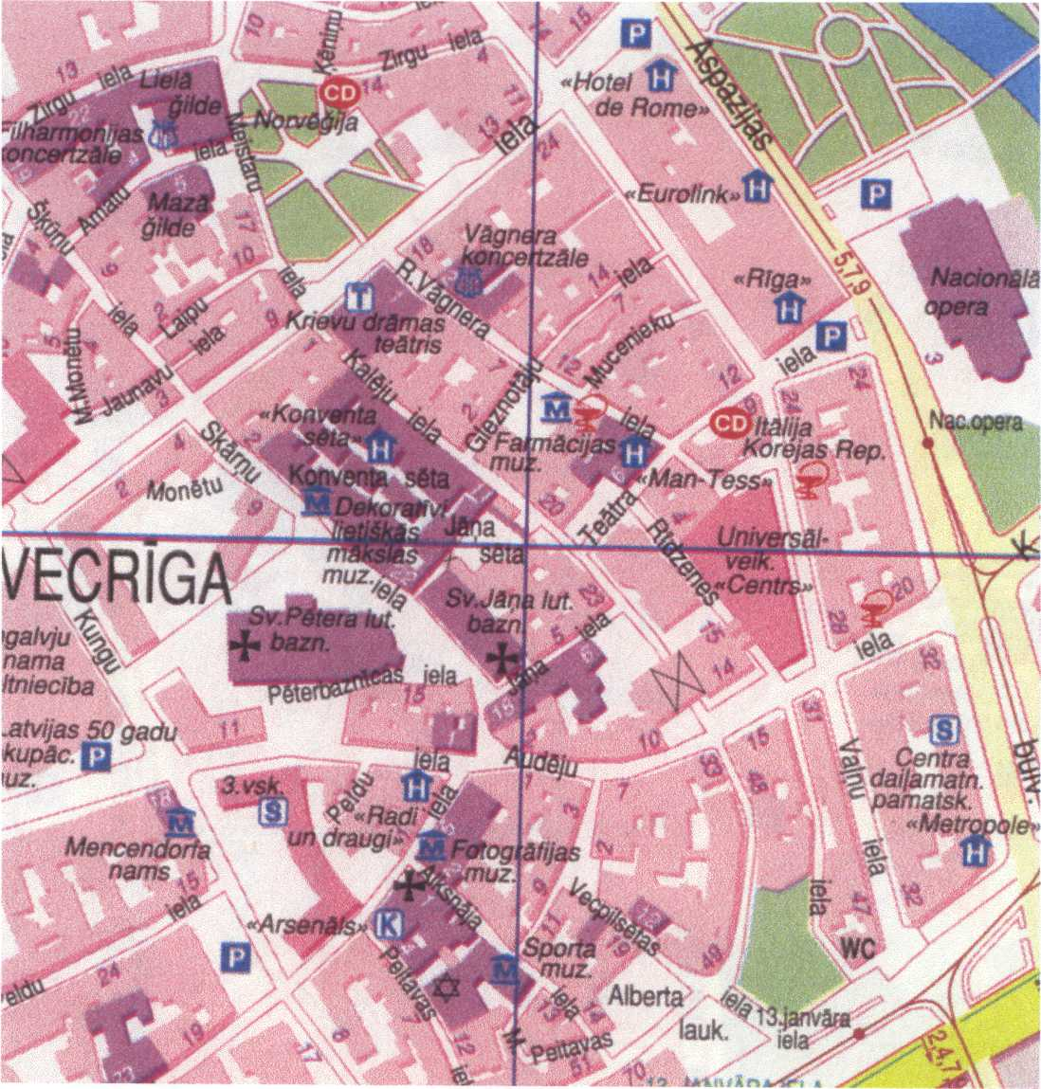

TELPISKO DATU RELĀCIJU MODELIS

Slānis
Nosaukums_SDOLAYER
Nosaukums_SDODIM
Nosaukums_SDOGEOM

Nosaukums_SDOINDEX
Paskaidrojošā tabula

SDOLAYER - slāņi.
SDODIM – dimensijas.
SDOGEOM – ģeometrijas.
SDOINDEX – indeksi.

ĢEOMETRISKO DATU RELĀCIJU – OBJEKTU MODELIS

Slānis
Galvenā tabula ar objektu kolonu
Tabula ar paskaidrojumiem

objektu kolona

Tabulā glabājamo ģeometrisko objektu tips SDO_GEOMETRY un tā elementi

Description of a spatial object is stored in a single row, in a single column of object type SDO_GEOMETRY in a user-defined table. Any table that has a column of type SDO_GEOMETRY must have another column, or set of columns, that defines a unique primary key for that table. Tables of this sort are sometimes referred to as spatial tables or spatial geometry tables.

create type SDO_GEOMETRY as object(
SDO_GTYPE number,
SDO_SRID number,
SDO_POINT SDO_POINT_TYPE,
SDO_ELEM_INFO SDO_ELEM_INFO_ARRAY,
SDO_ORDINATES SDO_ORDINATE_ARRAY);

create type SDO_POINT_TYPE as object(
X number,
Y number,
Z number);

create type SDO_ELEM_INFO_ARRAY as varray(1048576) of number;

create type SDO_ORDINATE_ARRAY as varray(1048576) of number;

SDO_ELEM_INFO SDO_ORDINATES
SDO_ SDO_ SDO_
GTYPE SRID POINT SDO_STARTING_OFFSET X1, Y1, X2, Y2, . . .

SDO_ETYPE

SDO_INTERPRETATION

SDO_GTYPE
The SDO_GTYPE attribute indicates the type of the geometry. Valid geometry types correspond to those specified in the Geometry Object Model for the OGIS Simple Features for SQL specification. The SDO_GTYPE value is 4 digits in the format d l t t, where:
- d identifies the number of dimensions (2, 3, or 4);
- l identifies the linear referencing measure dimension for a three-dimensional linear referencing system (LRS) geometry, that is, which dimension (3 or 4) contains the measure value. For a non-LRS geometry, or to accept the Spatial default of the last dimension as the measure for an LRS geometry, specify 0.
- tt identifies the geometry type (00 through 07, with 08 through 99 reserved for future use).
Value | Geometry Type | Description
dl00 | UNKNOWN_GEOMETRY | Spatial ignores this geometry.
dl01 | POINT | Geometry contains one point.
dl02 | LINE or CURVE | Geometry contains one line string that can contain straight or circular arc segments, or both. (LINE and CURVE are synonymous in this context.)
dl03 | POLYGON | Geometry contains one polygon with or without holes. For a polygon with holes, enter the exterior boundary first, followed by any interior boundaries.
dl04 | COLLECTION | Geometry is a heterogeneous collection of elements. Polygons in the collection can be disjoint. COLLECTION is a superset that includes all other types.
dl05 | MULTIPOINT | Geometry has one or more points. (MULTIPOINT is a superset of POINT.)
dl06 | MULTILINE or MULTICURVE | Geometry has one or more line strings. (MULTILINE and MULTICURVE are synonymous in this context, and each is a superset of both LINE and CURVE.)
dl07 | MULTIPOLYGON | Geometry can have multiple, disjoint polygons (more than one exterior boundary). (MULTIPOLYGON is a superset of POLYGON.)

The number of dimensions reflects the number of ordinates used to represent each vertex (for example, X,Y for two-dimensional objects). Points and lines are considered two-dimensional objects.
In any given layer (column), all geometries must have the same number of dimensions. For example, you cannot mix two-dimensional and three-dimensional data in the same layer.
The following methods are available for returning the individual dltt components of the SDO_GTYPE for a geometry object: GET_DIMS, GET_LRS_DIM, and GET_GTYPE.

SDO_SRID

The SDO_SRID attribute can be used to identify a coordinate system (spatial reference system) to be associated with the geometry. If SDO_SRID is null, no coordinate system is associated with the geometry. If SDO_SRID is not null, it must contain a value from the SRID column of the MDSYS.CS_SRS table, and this value must be inserted into the SRID column of the USER_SDO_GEOM_METADATA view.
All geometries in a geometry column must have the same SDO_SRID value.

SRID | NUMBER(38) | The unique ID number (Spatial Reference ID) for a coordinate system. Currently, SRID values 1-999999 are reserved for use by Oracle Spatial, and values 1000000 (1 million) and higher are available for user-defined coordinate systems.

SDO_POINT

The SDO_POINT attribute is defined using the SDO_POINT_TYPE object type, which has the attributes X, Y, and Z, all of type NUMBER.

create type SDO_POINT_TYPE as object(
X number,
Y number,
Z number);

If the SDO_ELEM_INFO and SDO_ORDINATES arrays are both null, and the SDO_POINT attribute is non-null, then the X and Y values are considered to be the coordinates for a point geometry. Otherwise, the SDO_POINT attribute is ignored by Spatial. You should store point geometries in the SDO_POINT attribute for optimal storage; and if you have only point geometries in a layer, it is strongly recommended that you store the point geometries in the SDO_POINT attribute.
Do not use the SDO_POINT attribute in defining a linear referencing system (LRS) point. For information about LRS.
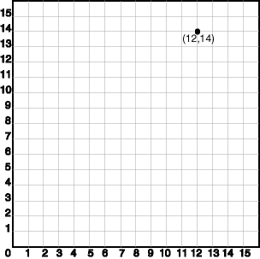
SDO_GTYPE = 2001. The 2 indicates two-dimensional, and the 1 indicates a single point.
SDO_SRID = NULL.
SDO_POINT = SDO_POINT_TYPE(12, 14, NULL). The SDO_POINT attribute is defined using the SDO_POINT_TYPE object type, because this is a point-only geometry.
SDO_ELEM_INFO and SDO_ORDINATES are both NULL, as required if the SDO_POINT attribute is specified.
INSERT INTO TABULA_G VALUES( 90, 'punkts A',
SDO_GEOMETRY(
2001,
NULL,
SDO_POINT_TYPE(12, 14, NULL),
NULL,
NULL));

SDO_ELEM_INFO

create type SDO_ELEM_INFO_ARRAY as varray(1048576) of number;

This attribute lets you know how to interpret the ordinates stored in the SDO_ORDINATES attribute.
Each triplet set of numbers (A, B, C) is interpreted as follows:
- SDO_STARTING_OFFSET - indicates the offset within the SDO_ORDINATES array where the first ordinate for this element is stored. Offset values start at 1 and not at 0. Thus, the first ordinate for the first element will be at SDO_GEOMETRY.SDO_ORDINATES(1). If there is a second element, its first ordinate will be at SDO_GEOMETRY.SDO_ORDINATES(n), where n reflects the position within the SDO_ORDINATE_ARRAY definition (for example, 19 for the 19th number).
- SDO_ETYPE - indicates the type of the element.
SDO_ETYPE values 1, 2, 1003, and 2003 are considered simple elements. They are defined by a single triplet entry in the SDO_ELEM_INFO array. For SDO_ETYPE values 1003 and 2003, the first digit indicates exterior (1) or interior (2):
1003: exterior polygon ring (must be specified in counterclockwise order)
2003: interior polygon ring (must be specified in clockwise order)
The use of 3 as an SDO_ETYPE value for polygon ring elements in a single geometry is discouraged. You should specify 3 only if you do not know if the simple polygon is exterior or interior. You cannot mix 1-digit and 4-digit SDO_ETYPE values in a single geometry. If you use 4-digit SDO_ETYPE values, you must use 4-digit SDO_GTYPE values.
SDO_ETYPE values 4, 1005, and 2005 are considered compound elements. They contain at least one header triplet with a series of triplet values that belong to the compound element. For SDO_ETYPE values 1005 and 2005, the first digit indicates exterior (1) or interior (2):
1005: exterior polygon ring (must be specified in counterclockwise order)
2005: interior polygon ring (must be specified in clockwise order)
The use of 5 as an SDO_ETYPE value for polygon ring elements in a single geometry is discouraged. You cannot mix 1-digit and 4-digit SDO_ETYPE values in a single geometry. If you use 4-digit SDO_ETYPE values, you must use 4-digit SDO_GTYPE values.
The elements of a compound element are contiguous. The last point of a subelement in a compound element is the first point of the next subelement. The point is not repeated.
- SDO_INTERPRETATION - means one of two things, depending on whether or not SDO_ETYPE is a compound element.
If SDO_ETYPE is a compound element (4, 1005, or 2005), this field specifies how many subsequent triplet values are part of the element.
If the SDO_ETYPE is not a compound element (1, 2, 1003, or 2003), the interpretation attribute determines how the sequence of ordinates for this element is interpreted. For example, a line string or polygon boundary may be made up of a sequence of connected straight line segments or circular arcs.
If a geometry consists of more than one element, then the last ordinate for an element is always one less than the starting offset for the next element. The last element in the geometry is described by the ordinates from its starting offset to the end of the SDO_ORDINATES varying length array.
For compound elements (SDO_ETYPE values 4, 1005, or 2005), a set of n triplets (one for each subelement) is used to describe the element. It is important to remember that subelements of a compound element are contiguous. The last point of a subelement is the first point of the next subelement. For subelements 1 through n-1, the end point of one subelement is the same as the starting point of the next subelement. The starting point for subelements 2...n-2 is the same as the end point of subelement 1...n-1. The last ordinate of subelement n is either the starting offset minus 1 of the next element in the geometry, or the last ordinate in the SDO_ORDINATES varying length array.
The current size of a varying length array can be determined by using the function varray_variable.Count in PL/SQL or OCICollSize in the Oracle Call Interface (OCI).

SDO_ETYPE | SDO_INTER  PRETATION | Meaning
0 | (any numeric value) | Type 0 (zero) element. Used to model geometry types not supported by Oracle Spatial.
1 | 1 | Point type.
1 | n > 1 | Point cluster with n points.
2 | 1 | Line string whose vertices are connected by straight line segments.
2 | 2 | Line string made up of a connected sequence of circular arcs.  Each circular arc is described using three coordinates: the arc's start point, any point on the arc, and the arc's end point. The coordinates for a point designating the end of one arc and the start of the next arc are not repeated. For example, five coordinates are used to describe a line string made up of two connected circular arcs. Points 1, 2, and 3 define the first arc, and points 3, 4, and 5 define the second arc, where point 3 is only stored once.
1003 or 2003 | 1 | Simple polygon whose vertices are connected by straight line segments. You must specify a point for each vertex, and the last point specified must be exactly the same point as the first (to close the polygon), regardless of the tolerance value. For example, for a 4-sided polygon, specify 5 points, with point 5 the same as point 1.
1003 or 2003 | 2 | Polygon made up of a connected sequence of circular arcs that closes on itself. The end point of the last arc is the same as the start point of the first arc.  Each circular arc is described using three coordinates: the arc's start point, any point on the arc, and the arc's end point. The coordinates for a point designating the end of one arc and the start of the next arc are not repeated. For example, five coordinates are used to describe a polygon made up of two connected circular arcs. Points 1, 2, and 3 define the first arc, and points 3, 4, and 5 define the second arc. The coordinates for points 1 and 5 must be the same (tolerance is not considered), and point 3 is not repeated.
1003 or 2003 | 3 | Rectangle type (sometimes called optimized rectangle). A bounding rectangle such that only two points, the lower-left and the upper-right, are required to describe it. The rectangle type can be used with geodetic or non-geodetic data. However, with geodetic data, use this type only to create a query window (not for storing objects in the database).
1003 or 2003 | 4 | Circle type. Described by three distinct non-colinear points, all on the circumference of the circle.
4 | n > 1 | Compound line string with some vertices connected by straight line segments and some by circular arcs. The value n in the Interpretation column specifies the number of contiguous subelements that make up the line string.  The next n triplets in the SDO_ELEM_INFO array describe each of these subelements. The subelements can only be of SDO_ETYPE 2. The last point of a subelement is the first point of the next subelement, and must not be repeated.
1005 or 2005 | n > 1 | Compound polygon with some vertices connected by straight line segments and some by circular arcs. The value n in the Interpretation column specifies the number of contiguous subelements that make up the polygon.  The next n triplets in the SDO_ELEM_INFO array describe each of these subelements. The subelements can only be of SDO_ETYPE 2. The end point of a subelement is the start point of the next subelement, and it must not be repeated. The start and end points of the polygon must be exactly the same point (tolerance is ignored).

Poligons ar iekšēju poligonu

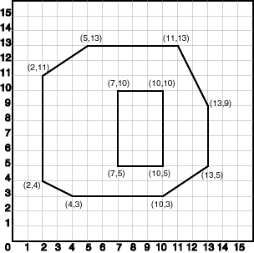
SDO_GTYPE = 2003.
2 indicates two-dimensional.
3 indicates a polygon.
SDO_SRID = NULL.
SDO_POINT = NULL.
SDO_ELEM_INFO = (1, 1003, 1,
19, 2003, 1). There are two triplet elements: 1, 1003, 1 and 19, 2003, 1.
1003 indicates that the element is an exterior polygon ring; 2003 indicates that the element is an interior polygon ring.
19 indicates that the second element (the interior polygon ring) ordinate specification starts at the 19th number in the SDO_ORDINATES array (that is, 7, meaning that the first point is 7, 5).
SDO_ORDINATES = (2,4, 4,3, 10,3, 13,5, 13,9, 11,13, 5,13, 2,11, 2,4, 7,5, 7,10, 10,10, 10,5, 7,5).
INSERT INTO TABULA_G VALUES( 10, 'poligons ar caurumu',
SDO_GEOMETRY(
2003,
NULL,
NULL,
SDO_ELEM_INFO_ARRAY(1, 1003, 1, 19, 2003, 1), -- polygon with hole
SDO_ORDINATE_ARRAY(2,4, 4,3, 10,3, 13,5, 13,9, 11,13, 5,13, 2,11, 2,4,
7, 5, 7,10, 10,10, 10,5, 7,5) ) );

The area (SDO_GEOM.SDO_AREA function) of the polygon is the area of the exterior polygon minus the area of the interior polygon. In this example, the area is 84 (99 - 15).
The perimeter (SDO_GEOM.SDO_LENGTH function) of the polygon is the perimeter of the exterior polygon plus the perimeter of the interior polygon. In this example, the perimeter is 52.9193065 (36.9193065 + 16).
An example of such a "polygon with a hole" might be a land mass (such as a country or an island) with a lake inside it. Of course, an actual land mass might have many such interior polygons: each one would require a triplet element in SDO_ELEM_INFO, plus the necessary ordinate specification.
Exterior and interior rings cannot be nested. For example, if a country has a lake and there is an island in the lake (and perhaps a lake on the island), a separate polygon must be defined for the island; the island cannot be defined as an interior polygon ring within the interior polygon ring of the lake.
In a multipolygon (polygon collection), rings must be grouped by polygon, and the first ring of each polygon must be the exterior ring. For example, consider a polygon collection that contains two polygons (A and B):
- Polygon A (one interior "hole"): exterior ring A0, interior ring A1
- Polygon B (two interior "holes"): exterior ring B0, interior ring B1, interior ring B2
The elements in SDO_ELEM_INFO and SDO_ORDINATES must be in one of the following orders (depending on whether you specify Polygon A or Polygon B first):
- A0, A1; B0, B1, B2
- B0, B1, B2; A0, A1

SDO_ORDINATES

The SDO_ORDINATES attribute is defined using a varying length array (1048576) of NUMBER type that stores the coordinate values that make up the boundary of a spatial object.

SDO_ORDINATES SDO_ORDINATE_ARRAY,

create type SDO_ORDINATE_ARRAY as varray(1048576) of number;

This array must always be used in conjunction with the SDO_ELEM_INFO varying length array. The values in the array are ordered by dimension. For example, a polygon whose boundary has four two-dimensional points is stored as {X1, Y1, X2, Y2, X3, Y3, X4, Y4, X1, Y1}. If the points are three-dimensional, then they are stored as {X1, Y1, Z1, X2, Y2, Z2, X3, Y3, Z3, X4, Y4, Z4, X1, Y1, Z1}. Spatial index creation, operators, and functions ignore the Z values because this release of the product supports only two-dimensional spatial objects.
The values in the SDO_ORDINATES array must all be valid and non-null. There are no special values used to delimit elements in a multielement geometry. The start and end points for the sequence describing a specific element are determined by the STARTING_OFFSET values for that element and the next element in the SDO_ELEM_INFO array, as explained previously. The offset values start at 1. SDO_ORDINATES(1) is the first ordinate of the first point of the first element.

Salikta līnija

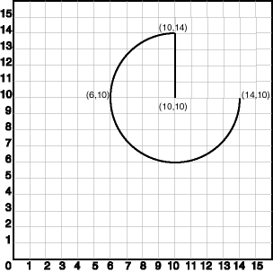
SDO_GTYPE = 2002. The first 2 indicates two-dimensional, and the second 2 indicates one or more line segments.
SDO_SRID = NULL.
SDO_POINT = NULL.
SDO_ELEM_INFO = (1,4,2, 1,2,1, 3,2,2). There are three triplet elements: 1,4,2, 1,2,1, and 3,2,2.
The first triplet indicates that this element is a compound line string made up of two subelement line strings, which are described with the next two triplets.
The second triplet indicates that the line string is made up of straight line segments and that the ordinates for this line string start at offset 1. The end point of this line string is determined by the starting offset of the second line string, 3 in this instance.
The third triplet indicates that the second line string is made up of circular arcs with ordinates starting at offset 3. The end point of this line string is determined by the starting offset of the next element or the current length of the SDO_ORDINATES array, if this is the last element.
SDO_ORDINATES = (10,10, 10,14, 6,10, 14,10).
insert intoTABULA_G values( 11, 'compound_line_string',
SDO_GEOMETRY(
2002,
NULL,
NULL,
SDO_ELEM_INFO_ARRAY(1,4,2, 1,2,1, 3,2,2), -- compound line string
SDO_ORDINATE_ARRAY(10,10, 10,14, 6,10, 14,10) ));

Salikts poligons

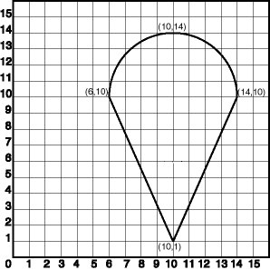
SDO_GTYPE = 2003
The 2 indicates two-dimensional.
3 indicates a polygon.

SDO_SRID = NULL

SDO_POINT = NULL
SDO_ELEM_INFO = (1, 1005, 2,
1, 2, 1, 5, 2, 2).
There are three triplet elements.

The first triplet indicates that this element is a compound polygon made up of two subelement line strings, which are described using the next two triplets.
The second triplet indicates that the first subelement line string is made up of straight line segments and that the ordinates for this line string start at offset 1. The end point of this line string is determined by the starting offset of the second line string, 5 in this instance. Because the vertices are two-dimensional, the coordinates for the end point of the first line string are at ordinates 5 and 6.
The third triplet indicates that the second subelement line string is made up of a circular arc with ordinates starting at offset 5. The end point of this line string is determined by the starting offset of the next element or the current length of the SDO_ORDINATES array, if this is the last element.
SDO_ORDINATES = (6, 10, 10,1, 14,10, 10,14, 6,10).
INSERT INTO TABULA_G VALUES(12, 'salikts poligons',
SDO_GEOMETRY(
2003, -- two-dimensional polygon
NULL,
NULL,
SDO_ELEM_INFO_ARRAY(1,1005,2, 1,2,1, 5,2,2), -- compound polygon
SDO_ORDINATE_ARRAY(6,10, 10,1, 14,10, 10,14, 6,10) ) );

Punkts

SDO_GTYPE = 2001. The 2 indicates two-dimensional, and the 1 indicates a single point.
SDO_SRID = NULL.
SDO_POINT = SDO_POINT_TYPE(12, 14, NULL). The SDO_POINT attribute is defined using the SDO_POINT_TYPE object type, because this is a point-only geometry.
SDO_ELEM_INFO = NULL SDO_ORDINATES = NULL.

INSERT INTO PUNKTI VALUES( 90, 'punkts', SDO_GEOMETRY(
2001,
NULL,
SDO_POINT_TYPE(12, 14, NULL),
NULL,
NULL));

Taisnstūris

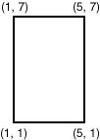
SDO_GTYPE = 2003. Divas (2) dimensijas un poligons (3).
SDO_SRID = NULL.
SDO_POINT = NULL.
SDO_ELEM_INFO = (1, 1003, 3). The final 3 in 1, 1003, 3 indicates that this is a rectangle. Because it is a rectangle, only two ordinates are specified in SDO_ORDINATES (lower-left and upper-right).
SDO_ORDINATES = (1, 1, 5, 7). These identify the lower-left and upper-right ordinates of the rectangle.
INSERT INTO TAISNSTURI VALUES( 1, 'Taisnstūris', SDO_GEOMETRY(
2003, -- two-dimensional polygon
NULL,
NULL,
SDO_ELEM_INFO_ARRAY(1,1003,3), -- one rectangle (1003 = āriene)
SDO_ORDINATE_ARRAY(1,1, 5,7) -- only 2 points needed to
-- define rectangle (lower left and upper right) with
-- Cartesian-coordinate data
) );

Poligons ar caurumu (gredzens)

SDO_GTYPE = 2003. The 2 indicates two-dimensional, and the 3 indicates a polygon.
SDO_SRID = NULL.
SDO_POINT = NULL.
SDO_ELEM_INFO = (1,1003,1, 19,2003,1). There are two triplet elements: 1,1003,1 and 19,2003,1. 1003 indicates that the element is an exterior polygon ring; 2003 indicates that the element is an interior polygon ring. 19 indicates that the second element (the interior polygon ring) ordinate specification starts at the 19th number in the SDO_ORDINATES array (that is, 7, meaning that the first point is 7,5).
SDO_ORDINATES = (2,4, 4,3, 10,3, 13,5, 13,9, 11,13, 5,13, 2,11, 2,4, 7,5, 7,10, 10,10, 10,5, 7,5).

INSERT INTO POLIGONI VALUES( 10, 'Poligons', SDO_GEOMETRY(
2003, -- two-dimensional polygon
NULL,
NULL,
SDO_ELEM_INFO_ARRAY(1,1003,1, 19,2003,1), -- polygon with hole
SDO_ORDINATE_ARRAY(2,4, 4,3, 10,3, 13,5, 13,9, 11,13, 5,13, 2,11, 2,4,
7,5, 7,10, 10,10, 10,5, 7,5) ) );

An example of such a "polygon with a hole" might be a land mass (such as a country or an island) with a lake inside it. Of course, an actual land mass might have many such interior polygons: each one would require a triplet element in SDO_ELEM_INFO, plus the necessary ordinate specification.
Exterior and interior rings cannot be nested. For example, if a country has a lake and there is an island in the lake (and perhaps a lake on the island), a separate polygon must be defined for the island; the island cannot be defined as an interior polygon ring within the interior polygon ring of the lake.
In a multipolygon (polygon collection), rings must be grouped by polygon, and the first ring of each polygon must be the exterior ring. For example, consider a polygon collection that contains two polygons (A and B):
- Polygon A (one interior "hole"): exterior ring A0, interior ring A1
- Polygon B (two interior "holes"): exterior ring B0, interior ring B1, interior ring B2
The elements in SDO_ELEM_INFO and SDO_ORDINATES must be in one of the following orders (depending on whether you specify Polygon A or Polygon B first):
- A0, A1; B0, B1, B2
- B0, B1, B2; A0, A1

Līnija, kas sastāv no diviem elementiem

SDO_GTYPE = 2002. The first 2 indicates two-dimensional, and the second 2 indicates one or more line segments.
SDO_SRID = NULL.
SDO_POINT = NULL.
SDO_ELEM_INFO = (1,4,2, 1,2,1, 3,2,2). There are three triplet elements: 1,4,2, 1,2,1 and 3,2,2.
The first triplet indicates that this element is a compound line string made up of two subelement line strings, which are described with the next two triplets.
The second triplet indicates that the line string is made up of straight line segments and that the ordinates for this line string start at offset 1. The end point of this line string is determined by the starting offset of the second line string, 3 in this instance.
The third triplet indicates that the second line string is made up of circular arcs with ordinates starting at offset 3. The end point of this line string is determined by the starting offset of the next element or the current length of the SDO_ORDINATES array, if this is the last element.
SDO_ORDINATES = (10,10, 10,14, 6,10, 14,10).
INSERT INTO cola_markets VALUES( 11, 'compound_line_string', SDO_GEOMETRY(
2002,
NULL,
NULL,
SDO_ELEM_INFO_ARRAY(1,4,2, 1,2,1, 3,2,2), -- compound line string
SDO_ORDINATE_ARRAY(10,10, 10,14, 6,10, 14,10) ) );

Salikts poligons
Five points are required to represent this shape: points (6,10), (10,1), and (14,10) describe one acute angle-shaped line string, and points (14,10), (10,14), and (6,10) describe the circular arc. The starting point of the line string and the ending point of the circular arc are the same point (6,10). The SDO_ELEM_INFO array contains three triplets for this compound line string. These triplets are {(1,1005,2), (1,2,1), (5,2,2)}.
SDO_GTYPE = 2003. The 2 indicates two-dimensional, and the 3 indicates a polygon.
SDO_SRID = NULL.
SDO_POINT = NULL.
SDO_ELEM_INFO = (1,1005,2, 1,2,1, 5,2,2). There are three triplet elements: 1,1005,2, 1,2,1, and 5,2,2.
The first triplet indicates that this element is a compound polygon made up of two subelement line strings, which are described using the next two triplets.

The second triplet indicates that the first subelement line string is made up of straight line segments and that the ordinates for this line string start at offset 1. The end point of this line string is determined by the starting offset of the second line string, 5 in this instance. Because the vertices are two-dimensional, the coordinates for the end point of the first line string are at ordinates 5 and 6.

The third triplet indicates that the second subelement line string is made up of a circular arc with ordinates starting at offset 5. The end point of this line string is determined by the starting offset of the next element or the current length of the SDO_ORDINATES array, if this is the last element.
SDO_ORDINATES = (6,10, 10,1, 14,10, 10,14, 6,10).
INSERT INTO cola_markets VALUES( 12, 'compound_polygon', SDO_GEOMETRY(
2003, -- two-dimensional polygon
NULL,
NULL,
SDO_ELEM_INFO_ARRAY(1,1005,2, 1,2,1, 5,2,2), -- compound polygon
SDO_ORDINATE_ARRAY(6,10, 10,1, 14,10, 10,14, 6,10) ) );

Pemēri SDO_GEOMETRY objektu kodējumiem
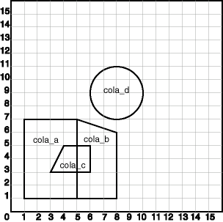

CREATE TABLE cola_markets (
mkt_id NUMBER PRIMARY KEY,
name VARCHAR2(32),
shape SDO_GEOMETRY);

INSERT INTO cola_markets VALUES(1, 'cola_a', SDO_GEOMETRY(
2003, -- two-dimensional polygon
NULL,
NULL,
SDO_ELEM_INFO_ARRAY(1,1003,3), -- one rectangle (1003 = exterior)
SDO_ORDINATE_ARRAY(1,1, 5,7)));

INSERT INTO cola_markets VALUES(2, 'cola_b', SDO_GEOMETRY(
2003, -- two-dimensional polygon
NULL,
NULL,
SDO_ELEM_INFO_ARRAY(1,1003,1), -- one polygon (exterior polygon ring)
SDO_ORDINATE_ARRAY(5,1, 8,1, 8,6, 5,7, 5,1)));

INSERT INTO cola_markets VALUES(3, 'cola_c', SDO_GEOMETRY(
2003, -- two-dimensional polygon
NULL,
NULL,
SDO_ELEM_INFO_ARRAY(1,1003,1), -- one polygon (exterior polygon ring)
SDO_ORDINATE_ARRAY(3,3, 6,3, 6,5, 4,5, 3,3)));

INSERT INTO cola_markets VALUES( 4, 'cola_d', SDO_GEOMETRY(
2003, -- two-dimensional polygon
NULL,
NULL,
SDO_ELEM_INFO_ARRAY(1,1003,4), -- one circle with a radius of 2
SDO_ORDINATE_ARRAY(8,7, 10,9, 8,11)));

-- Update the USER_SDO_GEOM_METADATA view. This is required
-- before the Spatial index can be created. Do this only once for each
-- layer (that is, table-column combination; here: COLA_MARKETS and SHAPE).

INSERT INTO USER_SDO_GEOM_METADATA VALUES ('cola_markets', 'shape',
SDO_DIM_ARRAY( -- 20X20 grid
SDO_DIM_ELEMENT('X', 0, 20, 0.005),
SDO_DIM_ELEMENT('Y', 0, 20, 0.005)),
NULL); -- SRID

-- CREATE THE R-tree SPATIAL INDEX --
CREATE INDEX cola_spatial_idx ON cola_markets(shape)
INDEXTYPE IS MDSYS.SPATIAL_INDEX;

-- PERFORM SOME SPATIAL QUERIES --
-- Return the topological intersection of two geometries.
SELECT SDO_GEOM.SDO_INTERSECTION(c_a.shape, c_c.shape, 0.005)
FROM cola_markets c_a, cola_markets c_c
WHERE c_a.name = 'cola_a' AND c_c.name = 'cola_c';

-- Do two geometries have any spatial relationship?
SELECT SDO_GEOM.RELATE(c_b.shape, 'anyinteract', c_d.shape, 0.005)
FROM cola_markets c_b, cola_markets c_d
WHERE c_b.name = 'cola_b' AND c_d.name = 'cola_d';

-- Return the areas of all cola markets.
SELECT name, SDO_GEOM.SDO_AREA(shape, 0.005) FROM cola_markets;

-- Return the area of just cola_a.
SELECT c.name, SDO_GEOM.SDO_AREA(c.shape, 0.005) FROM cola_markets c
WHERE c.name = 'cola_a';

-- Return the distance between two geometries.
SELECT SDO_GEOM.SDO_DISTANCE(c_b.shape, c_d.shape, 0.005)
FROM cola_markets c_b, cola_markets c_d
WHERE c_b.name = 'cola_b' AND c_d.name = 'cola_d';

-- Is a geometry valid?
SELECT c.name, SDO_GEOM.VALIDATE_GEOMETRY_WITH_CONTEXT(c.shape, 0.005)
FROM cola_markets c WHERE c.name = 'cola_c';

-- Is a layer valid? (First, create the results table.)
CREATE TABLE val_results (sdo_rowid ROWID, result VARCHAR2(2000));
CALL SDO_GEOM.VALIDATE_LAYER_WITH_CONTEXT('COLA_MARKETS', 'SHAPE',
'VAL_RESULTS', 2);
SELECT * from val_results;

Nulles (0) tipa grafiskais elements
Type 0 (zero) elements are used to model geometry types that are not supported by Oracle Spatial, such as curves and splines. A type 0 element has an SDO_ETYPE value of 0. Type 0 elements are not indexed by Oracle Spatial, and they are ignored by Spatial functions and procedures.
Geometries with type 0 elements must contain at least one nonzero element, that is, an element with an SDO_ETYPE value that is not 0. The nonzero element should be an approximation of the unsupported geometry, and therefore it must have both:
- An SDO_ETYPE value associated with a geometry type supported by Spatial
- An SDO_INTERPRETATION value that is valid for the SDO_ETYPE value
(The SDO_INTERPRETATION value for the type 0 element can be any numeric value, and applications are responsible for determining the validity and significance of the value.)
The nonzero element is indexed by Spatial, and it will be returned by the spatial index.
The SDO_GTYPE value for a geometry containing a type 0 element must be set to the value for the geometry type of the nonzero element.
Figure shows a geometry with two elements: a curve (unsupported geometry) and a rectangle (the nonzero element) that approximates the curve. The curve looks like the letter S, and the rectangle is represented by the dashed line.
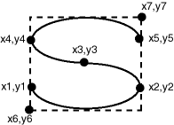
The SDO_GTYPE value for the geometry is 2003 (for a two-dimensional polygon).
The SDO_ELEM_INFO array contains two triplets for this compound line string. For example, the triplets might be {(1,0,57), (11,1003,3)}. That is:
Ordinate Starting Offset  (SDO_STARTING_OFFSET) | Element Type  (SDO_ETYPE) | Interpretation  (SDO_INTERPRETATION)
1 | 0 | 57
11 | 1003 | 3

In this example:
- The type 0 element has an SDO_ETYPE value of 0.
- The nonzero element (rectangle) has an SDO_ETYPE value of 1003, indicating an exterior polygon ring.
- The nonzero element has an SDO_STARTING_OFFSET value of 11 because ordinate x6 is the eleventh ordinate in the geometry.
- The type 0 element has an SDO_INTERPRETATION value whose significance is application-specific. In this example, the SDO_INTERPRETATION value is 57.
- The nonzero element has an SDO_INTERPRETATION value that is valid for the SDO_ETYPE of 1003. In this example, the SDO_INTERPRETATION value is 3, indicating a rectangle defined by two points (lower-left and upper-right).
Example shows a SQL statement that inserts the geometry with a type 0 element into the database. In the SDO_ORDINATE_ARRAY structure, the curve is defined by points (6,6), (12,6), (9,8), (6,10), and (12,10), and the rectangle is defined by points (6,4) and (12,12).
INSERT INTO cola_markets VALUES( 13, 'type_zero_element_geom', SDO_GEOMETRY(
2003, -- two-dimensional polygon
NULL,
NULL,
SDO_ELEM_INFO_ARRAY(1,0,57, 11,1003,3), -- 1st is type 0 element
SDO_ORDINATE_ARRAY(6,6, 12,6, 9,8, 6,10, 12,10, 6,4, 12,12) ) );

